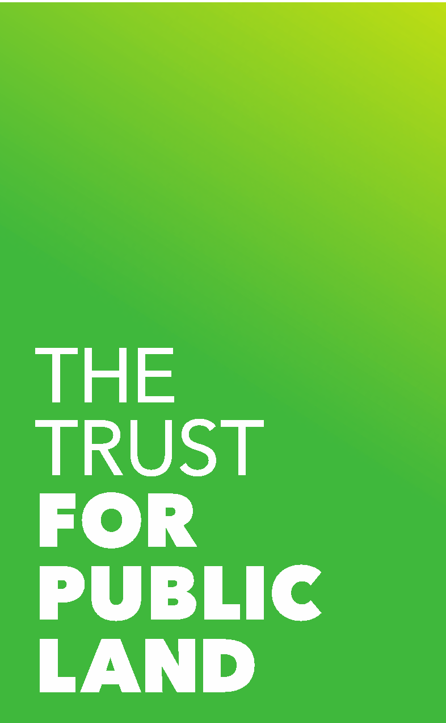

Embargoed Until Contact: Laura H. Aplin
May 20, 2020, 12:01 a.m. EDT laura@lhapr.com

As Parks Reopen amid COVID-19 Crisis, Plano Ranks as Area’s Best Park System on Trust for Public Land’s Annual ParkScore Index

Plano Earns Highest Ranking among Six Area Cities, Placing 17th;
Dallas Ranks 54th; Arlington Improves to 59th; Garland 83rd; Irving 89th; and Fort Worth Dips to 94th

ParkScore Reports Sharp Increase in Park and Trail Use Nationally, but Experts Sound Alarm over Park Inequities and Risk of Budget Cuts

Dallas – As state and municipal leaders continue reopening parks and open spaces as the world weathers the COVID-19 pandemic, The Trust for Public Land announced that Plano earned the highest ranking among area cities on the annual 2020 ParkScore index. Arlington made a major upward move in the annual ranking of the 100 largest U.S. cities, climbing to 59th, compared to last year’s 68th place finish. Atop the ParkScore rankings, Minneapolis reclaimed the national title, pushing Washington, DC, into 2nd.

The nonprofit organization reported progress for parks across the nation, but also warned that city park systems have reached a critical tipping point, as widening inequities in equitable park access and COVID-related budget cuts risk irreversible damage in 2020 and beyond.

“When stay-at-home orders permitted, people increasingly turned to parks, trails, and public open spaces to connect with nature, exercise, and enhance their mental and physical health. Residents deeply value parks, but continued inequity and the risk of future budget cuts threaten severe damage to the park systems that make many cities so livable,” says Diane Regas, President and CEO of The Trust for Public Land.

Area parks, trails, and golf courses are mostly open, although park amenities, such as playgrounds and restrooms, are mostly closed.

PARKSCORE RANKINGS RELEASED FOR 2020

According to the Trust for Public Land’s ninth annual ParkScore® index, Minneapolis, Minn., has the best city park system in the country. The city pulled slightly ahead of 2019 champion Washington, DC, largely because of new park acquisitions and strategic expansions. DC fell to second, and St. Paul, Minn., finished third. Minneapolis has held the top spot in four of the past five years. The annual ParkScore Index evaluates park systems in the 100 most populous U.S. cities.

Plano remains the highest-ranking area city park system, while Arlington recorded the most progress in this year’s ParkScore index.

DFW Metro Area ParkScore Results, Summary Table
 | 2020 Rank | 2019 Rank | 2018 Rank
Plano | 17th | 15th | 18th
Dallas | 54th | 52nd | 49th
Arlington | 59th | 68th | 63rd
Garland | 83rd | 80th | 72nd
Irving | 89th | 88th | 82nd (Tie)
Fort Worth | 94th | 89th | 82nd (Tie)

Plano received high marks for its large median park size of 13.5 acres, more than double the national ParkScore average of 5.2 acres. Plano was also the only area city to receive above-average marks for park access. According to ParkScore, 75 percent of Plano residents live within a 10-minute walk of a park. Nationally, only 72 percent of ParkScore city residents meet the 10-minute standard. However, Plano’s overall ranking was hurt by low scores for park amenities, including dog parks, recreation and senior centers, and splashpads.
Arlington also features a large median park size (12.6 acres), and its ParkScore was lifted by a significant increase in parks spending this year, to $102 per resident, up from $92 last year and significantly above the national ParkScore average of $89. However, only 58 percent of Arlington residents live within a 10-minute walk of a park.
Dallas features a large median park size of 7.7 acres, which is above the national ParkScore median of 5.2 acres. The city’s park access score has improved dramatically over the past five years and now ranks close the national ParkScore average, thanks largely to new trail creation and joint use agreements that open school campuses for public use after school hours. However, its Dallas’ overall ranking was hurt by comparatively low scores for park amenities, especially dog parks and restrooms.
Garland followed the same ParkScore pattern, with a large median park size (9.6 acres) but below-average marks for park access (63 percent of residents within a 10-minute walk). Garland’s ParkScore was also hurt by below-average marks for park amenities. The city offers no dog parks or splashpads.
Irving reported a high number of playgrounds per resident (3.0 per 10,000, above the national ParkScore average of 2.6). However, the city’s ParkScore ranking was negatively affected by below-average park access marks. Only 64 percent of residents live within a 10-minute walk of a park, compared to the national ParkScore average of 72 percent.
Fort Worth received above-average scores for median park size (7.7 acres) but also received low scores for park amenities. The city provides only 1.2 basketball hoops per 10,000 residents, less than half the national ParkScore city average of 3.2. It also operates only 0.1 splashpads per 100,000 residents, well under the ParkScore median of 1.2

Boston, Mass., reached the Top Ten for the first time since 2016, landing in ninth place and pushing rival New York into 11th position. Boston and San Francisco, Calif. (eighth place), are the only ParkScore cities where 100 percent of residents have a park of public open space within a 10-minute walk of home.

Boise, Idaho, defended its title as the best park system for dogs, with a nation-leading 6.0 dog parks per 100,000 residents, narrowly beating Portland, Ore. Irvine, Calif., received top marks for basketball hoops, Madison, Wis., scored best for playgrounds, and Cleveland, Ohio, earned top marks for splash pads and other water features.

ParkScore reports that the number of playgrounds available nationally increased by 3.6 percent since last year, largely because of “shared use” agreements that open school playgrounds for neighborhood use after school hours and on weekends. The number of dog parks increased by nearly four percent, continuing the trend first reported by The Trust for Public Land five years ago.

INEQUITY AND COVID-RELATED BUDGET CUTS TOP PARKSCORE CONCERNS

ParkScore reports significant inequities in park access between large city park systems. For example, more than 98 percent of residents in ParkScore’s three highest ranking park systems (Minneapolis, Washington, and Saint Paul) enjoy 10-minute walk access to a park, compared to 47 percent in the three lowest ranking systems (Charlotte, N.C., Mesa, Ariz., and Oklahoma City, Okla.).

“Across the United States, 100 million people—including 28 million children—lack access to a quality park close to home. These inequities exist not only between cities but also within them. Low-income neighborhoods do not get their fair share of park investment, which is a missed opportunity to prevent long-term health and climate inequities. At the Trust for Public Land, we are striving for a park-rich future that offers inclusive public space for everyone to lead healthier, happier, lives,” says Diane Regas, President and CEO of The Trust for Public Land.

“Parks are a critical part of health and wellness—reducing anxiety, stress, and depression and improving physical health—all the more necessary during this public health emergency,” says Sadiya Muqueeth, DrPH, MPH, Director of Community Health at the Trust for Public Land. “Sunlight, fresh air, exercise, and access to nature all have a positive effect on our physical health and emotional wellbeing.”

Analysts at The Trust for Public Land also warned that the economic downturn caused by the COVID-19 pandemic will strain municipal budgets and threaten progress on parks. Last week, Dallas furloughed 235 Park and Recreation Department employees, citing a $25 million budget shortfall.

k

Following the 2007-2008 economic crisis, parks budgets were slashed across the nation by approximately 20 percent, which slowed new park acquisition and improvements for several years.

PARKSCORE METHODOLOGY AND RANKINGS

ParkScore rankings are based equally on four factors: park access, which measures the percentage of residents living within a 10-minute walk of a park; park acreage, which is based on a city’s median park size and the percentage of city area dedicated to parks; park investment, which measures park spending per resident; and park amenities, which counts the availability of six popular park features: basketball hoops, off-leash dog parks, playgrounds, “splash pads” and other water play structures, recreation and senior centers, and restrooms.

According to The Trust for Public Land, the 10 highest ranking park systems in the United States are:

Rank City ParkScore (Max: 100)
1. Minneapolis, MN 85.3
2. Washington, DC 83.3
3. Saint Paul, MN 82.5
4. Arlington, VA 81.5
5. Cincinnati, OH 80.6
6. Portland, OR 79.8
7. Irvine, CA 79.6
8. San Francisco, CA 78.9
9. Boston, MA 76.5
10. Chicago, IL 76.0

The lowest-ranking park systems are:

90. Hialeah, FL 33.1
91. Baton Rouge, LA 32.0
92. Fresno, CA 31.8
93. Lubbock, TX 31.6
94. Ft. Worth, TX 31.2
95. Charlotte, NC 29.8
96. Mesa, AZ 29.0
97. Oklahoma City 23.8

Fort Wayne, Ind., and Indianapolis, Ind., declined to participate in ParkScore 2020 and were not ranked. Gilbert, Ariz., was not ranked because the necessary data was unavailable.

The ParkScore Index uses advanced GIS (Geographic Information Systems) computer mapping technology to create digital maps evaluating park accessibility. Instead of measuring distance to a local park, the rating system’s GIS technology considers the location of park entrances and physical obstacles to access. For example, if residents are separated from a nearby park by a major highway, the ParkScore Index does not count the park as accessible to those residents, unless there is a bridge, underpass, or easy access point across the highway. The Trust for Public Land collaborated with GIS industry leader Esri on GIS design and implementation.

Municipal leaders use ParkScore information to guide park improvement efforts, studying park access on a block-by-block basis and pinpointing the areas where new parks are needed most. The ParkScore website, www.tpl.org/parkscore, is free and available to the public, empowering residents to hold their elected leaders accountable for achieving equitable access to quality parks for all.

About the Trust for Public Land

The Trust for Public Land creates parks and protects land for people, ensuring healthy, livable communities for generations to come. Millions of people live within a 10-minute walk of a Trust for Public Land park, garden, or natural area, and millions more visit these sites every year. To support The Trust for Public Land and share why nature matters to you, visit www.tpl.org.

###

