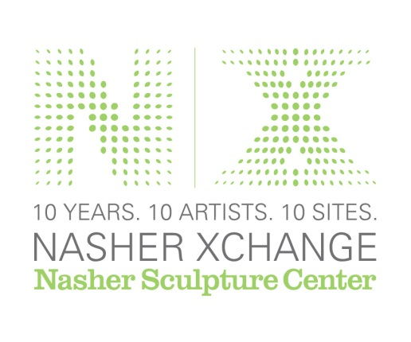

Nasher Sculpture Center Commissions New Project
by Good/Bad Art Collective at Downtown’s Bryan Tower
for City-Wide, Public Art Exhibition Nasher XChange
First citywide, museum-organized public sculpture exhibition in the United States to feature 10 works throughout Dallas; On view October 19, 2013 to February 16, 2014 in celebration of Nasher’s 10th anniversary
DALLAS, Texas (Friday, August 2) -- The Nasher Sculpture Center is pleased to reveal the plans for a newly commissioned project by Good/Bad Art Collective for Bryan Tower, a 40-story office building located in downtown Dallas. The work is one of ten commissions created for the Nasher’s 10th anniversary, city-wide exhibition Nasher XChange which runs October 19, 2013 through February 16, 2014.

Good/Bad Art Collective is a Denton, Texas based group of artists that created well over 250 events in Texas and New York from 1993-2001. For the Nasher XChange exhibition, the Good/Bad Art Collective is creating a project entitled CURTAINS that will be part one-night event, part exhibition and part television broadcast exploring notions of viewership and interaction. The Collective’s XChange project will be their ﬁrst major project in more than 10 years, and coincides with the 20th anniversary of the group.

In the months leading up to the opening of XChange, the Collective will produce a 28-minute infomercial, which will be filmed in a newly created television studio on an empty floor of Bryan Tower, a downtown Dallas highrise managed by Spire Realty. At the one-night opening event on Saturday, October 19, 2013, attendees will be given the opportunity to participate in the filming of the infomercial. Visitors throughout the run of XChange will be able to walk the space in which the infomercial was filmed and see sculptural elements used as props during the opening and in the finished infomercial, as well as select edits of video documenting the one-night event. The finished infomercial will be broadcast on late night and early morning television timeslots in local, regional, and national markets.

Throughout its ten year history over 110 artists and creatives were members of the Good/Bad Art Collective, developing unique one-night events of art, music, and film programming at a break-neck pace, resulting in what The Village Voice described as “Fluxus with ADD.” Partly inspired by conceptual art programs at the University of North Texas offered by artist Vernon Fisher, the group created installations and events that were often interactive, humorous, and thought-provoking.

Past large-scale projects include Very Fake, But Real (1997), a one-night-only event at DiverseWorks Art Space, Houston, in which they built an exact replica of their Denton studio inside the gallery and used the surrounding interior space as a roller skating rink and concert hall; and We’re On Our Way to Dinner, But We Have to Pick Up Something First (1999) for a photography exhibition at the Arlington Museum of Art in which they transformed the mezzanine of the museum into a 1970s-style garden apartment building and used one of the spaces to throw impromptu surprise parties for each of the guests at the opening, installing the polaroid photographs on the apartment refrigerator for the duration of the exhibition.

The Nasher has also commissioned Ruben Ochoa, Rick Lowe, Ugo Rondinone, Alfredo Jaar, Vicki Meek, Charles Long, Liz Larner, Lara Almarcegui, and Rachel Harrison to create works for Nasher XChange. Details about their works, including the locations of the installations, will be announced throughout the summer.

Download Images of Bryan Tower Here:
https://www.dropbox.com/sh/27g7fnsn7j4436m/3NiAtV4Rb-
(Caption: Allison V. Smith for the Nasher Sculpture Center)

Download image of Good/Bad Art Collective Nasher XChange Visual:
https://www.dropbox.com/sh/7npeu8rljmt51fs/A4FrEZNI23

About the Nasher Sculpture Center:
Open since 2003 and located in the heart of the Dallas Arts District, the Nasher Sculpture Center is home to one of the finest collections of modern and contemporary sculptures in the world, the Raymond and Patsy Nasher Collection, featuring more than 300 masterpieces by Calder, Giacometti, Matisse, Picasso, Rodin, and more. The longtime dream of the late Raymond and Patsy Nasher, the museum was designed by world-renowned architect Renzo Piano in collaboration with landscape architect Peter Walker.

Hailed by the "USA Today" as one of the great sculpture gardens where art enhances nature, the roofless museum seamlessly integrates the indoor galleries with the outdoor spaces creating a museum experience unlike any other in the world. On view in the light-filled galleries and amid the landscaped grounds are rotating works from the Collection, as well as blockbuster exhibitions and one-of-a-kind installations by the most celebrated artists of our times. In addition to the indoor and outdoor gallery spaces, the Center contains an auditorium, education and research facilities, a cafe, and a store.

The Nasher brings the best of contemporary culture to Dallas through special programs designed to engage visitors, including artist talks, lecture programs, contemporary music concerts, educational classes and exclusive member events.
The Nasher Sculpture Center is open Tuesday through Sunday from 11 am to 5 pm and until 11 pm for special events, and from 10 am to 5 pm on the first Saturday of each month. Admission is $10 for adults, $7 for seniors, $5 for students, and free for members and children 12 and under, and includes access to special exhibitions. For more information, visit www.NasherSculptureCenter.org.

###

For more information and photos, please contact:

Kristen Mills Gibbins
Associate Director of Media Relations
972.514.2099
kgibbins@NasherSculptureCenter.org

Megan Radke
Social Media and PR Coordinator
214.242.5162
mradke@NasherSculptureCenter.org

